CLASS 12TH Unit 3: Making Machines
A. Multiple Choice Questions
Que. 1) The field of study that helps to develop techniques to help computers “see” is __________.
a. Python b. Convolution c. Computer Vision d. Data Analysis
Ans:- c. Computer Vision
Que. 2) Task of taking an input image and outputting/assigning a class label that best describes the image is __________.
a. Image classification b. Image localization c. Image Identification d. Image prioritization
Ans:- a. Image classification
Que. 3) Identify the incorrect option.
(i) Computer vision involves processing and analysing digital images and videos to understand their content.
(ii) A digital image is a picture that is stored on a computer in the form of a sequence of numbers that computers can understand.
(iii) RGB colour code is used only for images taken using cameras.
(iv) Image is converted into a set of pixels and less pixels will resemble the original image.
a. ii b. iii c. iii & iv d. ii & iv
Ans:- c. iii & iv
Que. 4) The process of capturing a digital image or video using a digital camera, a scanner, or other imaging devices is related to __________.
a. Image Acquisition b. Preprocessing c. Feature Extraction d. Detection
Ans:- a. Image Acquisition
Que. 5) Which algorithm may be used for supervised learning in computer vision?
a. KNN b. K-means c. K-fold d. KEAM
Ans:- a. KNN
Que. 6) A computer sees an image as a series of __________.
a. colours b. pixels c. objects d. all of the above
Ans:- b. pixels
Que. 7) __________ empowers computer vision systems to extract valuable insights and drive intelligent decision-making in various applications, ranging from autonomous driving to medical diagnostics.
a. Low level processing b. High insights c. High-level processing d. None of the above
Ans:- c. High-level processing
Que. 8) In Feature Extraction, which technique identifies abrupt changes in pixel intensity and highlights object boundaries?
a. Edge detection b. Corner detection c. Texture Analysis d. Boundary detection
Ans:- a. Edge detection
Que. 9) Choose the incorrect statement related to preprocessing stage of computer vision.
a. It enhances the quality of acquired image.
b. Noise reduction and Image normalization is often employed with images.
c. Techniques like histogram equalization can be applied to adjust the distribution of pixel intensities.
d. Edge detection and corner detection are ensured in images.
Ans:- d. Edge detection and corner detection are ensured in images.
Que. 10) 1 byte = __________ bits.
a. 10 b. 8 c. 2 d. 1
Ans:- b. 8
B. Short Answer Questions
Que. 1) What is Computer Vision?
Ans:- Computer Vision is a field of Artificial Intelligence (AI) that enables computers to see, observe and understand the visual world. It uses sensing devices, data and deep learning models to process and interpret digital images, videos and other visual inputs.
Que. 2) What is the main difference between classification and detection?
Ans:- Classification determines the category or class to which an image or a single object belongs, whereas object detection identifies and locates multiple objects in an image by drawing bounding boxes around them and assigning class labels.
Que. 3) Write down any two algorithms which can be used for object detection.
Ans:- Two algorithms used for object detection are R-CNN (Region-Based Convolutional Neural Network) and YOLO (You Only Look Once). Other algorithms mentioned in the chapter are R-FCN and SSD.
Que. 4) Write down the process of object detection in a single object.
Ans:- In a single-object task, the image is first analysed to determine the class of the object. In classification, the category or class of the object is identified, while in classification with localization, the object is classified and its exact location is identified using a bounding box.
Que. 5) Write any four applications of Computer Vision.
Ans:- Four applications of Computer Vision are facial recognition, healthcare, self-driving vehicles and optical character recognition (OCR). Computer Vision is also used in machine inspection, 3D model building, surveillance, and fingerprint recognition and biometrics.
C. Long Answer Questions
Que. 1) What do you mean by Image Segmentation? Explain the popular segmentations.
Introduction:
Image segmentation is a computer vision process in which an image is divided by identifying pixels with similar characteristics and assigning them to different classes. It creates a pixel-wise mask around objects and helps in understanding an image at a detailed level.
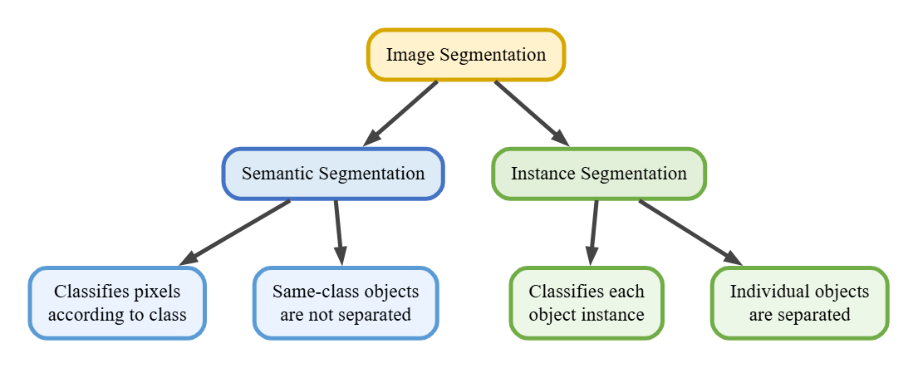
Diagram:

1. Semantic Segmentation: It classifies pixels that belong to a particular class. Objects belonging to the same class are not differentiated.
2. Instance Segmentation: It classifies pixels belonging to a particular object instance. It differentiates individual objects even when they belong to the same class.
3. Pixel-wise Identification: In image segmentation, pixels are assigned to a class and a pixel-wise mask is created for the objects present in the image.
4. Difference between the Segmentations: Semantic segmentation identifies objects according to their class, whereas instance segmentation identifies individual objects separately, even if they belong to the same class.
5. Importance: Image segmentation helps in gaining a better understanding of an image at a granular level and makes it easier to identify different objects separately.
Conclusion:- Thus, image segmentation is an important computer vision technique for analysing images at the pixel level. Semantic segmentation focuses on classes, while instance segmentation focuses on individual objects.
Que. 2) Explain the challenges faced by computer vision.
Introduction:
Computer Vision is an important field of Artificial Intelligence, but it faces several challenges while processing and interpreting visual information accurately. These challenges affect the quality, reliability and responsible use of computer vision systems.
Diagram: 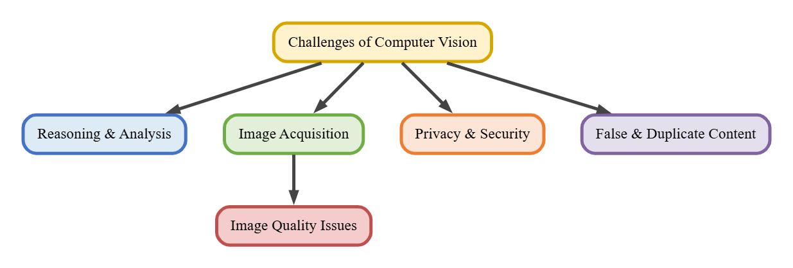
1. Computer Vision requires more than simple image identification. It must accurately interpret visual content and extract meaningful information. Lack of proper reasoning and analytical capability can limit its effectiveness.
2. Obtaining high-quality images can be difficult because of lighting variations, different perspectives, changes in scale, complex scenes and occlusion of objects.
3.: Different lighting conditions and camera angles can affect the quality of captured images, which may make accurate analysis and interpretation more difficult.
4. Technologies such as facial recognition and surveillance can raise serious privacy and security concerns. Their use may create ethical issues and therefore requires careful consideration of privacy implications.
5. Image and video processing systems can be misused to create or spread duplicate, misleading or fraudulent content. Such content can result in misinformation and reputational damage.
Conclusion:
Thus, the major challenges of Computer Vision include reasoning difficulties, image acquisition problems, image quality issues, privacy and security concerns, and false or duplicate content. These challenges need to be carefully addressed for effective and responsible use of Computer Vision.

